Title
Optimal strategy for discovering Z’ particles from proton collisions simulation
Abstract
This study investigates an optimal strategy for detecting a hypothetical Z′ boson using invariant mass analysis of simulated proton–proton collision data. The motivation arises from the limitations of the Standard Model, which cannot fully explain phenomena such as dark matter and therefore motivates the search for new particles. Events containing two oppositely charged electrons are selected, and their invariant mass is reconstructed to identify potential Z′ signals.
The analysis compares background-only and signal-plus-background hypotheses using weighted histograms constructed from simulated datasets. To quantify the detectability of the signal, statistical significance is evaluated for different mass window selections. By systematically scanning the mass window width for each Z′ mass hypothesis, an optimal selection strategy is determined.
The results show that the optimal mass window is approximately 8–10 GeV for all tested masses. In addition, the statistical significance decreases with increasing Z′ mass, indicating reduced sensitivity at higher energies. These findings demonstrate that invariant mass reconstruction combined with statistical optimization provides an effective approach for identifying potential signals of new particles.
Introduction
The Standard Model is a highly successful theoretical framework that describes the fundamental particles and their interactions with remarkable accuracy. It has been extensively tested and confirmed in a wide range of high-energy experiments. However, despite its success, the Standard Model is incomplete. It does not account for several important phenomena, including dark matter, neutrino masses, and gravity.[2] These limitations indicate that the Standard Model is only an effective theory and that new physics must exist beyond it. As a result, the search for new particles has become a central goal in modern particle physics.
One possible extension of the Standard Model involves the existence of a new heavy neutral gauge boson, commonly referred to as the Z′ boson. Many theoretical models predict such a particle, which could mediate new interactions or serve as a bridge between Standard Model particles and a hidden sector, such as dark matter.[3] In collider experiments, the Z′ boson can decay into an electron–positron pair, providing a relatively clean and experimentally accessible signature. However, background processes, such as virtual photon production, can produce the same final state, making it challenging to distinguish signal events from background.
The search for a Z′ boson is therefore important because it provides a direct test of physics beyond the Standard Model. Detecting such a particle would offer strong evidence for new fundamental interactions and could help address unresolved problems such as the nature of dark matter. To improve the likelihood of detecting a Z′ signal, it is necessary to develop optimized analysis strategies that enhance the separation between signal and background.
In simulated proton–proton collision data, the Z′ boson can have a range of possible masses, and its signal must be identified within a large background. To quantify the detectability of the signal, statistical significance is used, defined as $S/\sqrt{B}$, where $S$ and $B$ represent the number of signal and background events within a selected mass window.
This study aims to develop a systematic method for detecting a Z′ boson using invariant mass analysis of simulated data. Specifically, the invariant mass distributions of electron–positron pairs are reconstructed and used to compare the background-only and signal-plus-background hypotheses. By scanning different mass windows and evaluating the resulting statistical significance, the optimal detection strategy for each mass hypothesis is determined. This approach demonstrates how statistical methods and invariant mass reconstruction can be combined to enhance sensitivity in searches for new particles.

Methods
The analysis begins with selecting candidate events from the simulated dataset. Each event contains information about the number of detected electrons and their corresponding kinematic variables, including transverse momentum ($p_{T}$), pseudorapidity ($η$), azimuthal angle ($ϕ$), and electric charge. A typical data entry consists of an event header specifying the number of electrons, followed by the properties of each electron. For example:

NumElectrons: 1
Electron 1 Pt 121.893 Eta 2.339 Phi -1.938 Charge -1
NumElectrons: 2
Electron 1 Pt 103.414 Eta 1.457 Phi -0.779 Charge 1
Electron 2 Pt 73.405 Eta 1.876 Phi 2.256 Charge -1

To isolate events consistent with Z′ boson decay, only events containing exactly two electrons with opposite electric charge are selected. Events with fewer or more electrons, or with electrons of the same charge, are discarded. This selection criterion ensures that the remaining events are consistent with the expected $Z^{'}→e^{+}+e^{-}$decay signature.[1]

To identify the presence of a Z′ boson, the invariant mass of electron–positron pairs is reconstructed using four-momentum conservation. In particle physics, each particle is described by a four-momentum vector $p=(E,p)$, where $E$is the energy and $p=(p_{x},p_{y},p_{z})$is the three-momentum. [1]
The momentum components of each electron are obtained from the detector variables $p_{T}$, $η$, and $ϕ$, which are converted into Cartesian coordinates using the relations: [1]
$$p_{x}=p_{T}\cos{ϕ} \\ p_{y}=p_{T}\sin{ϕ} \\ p_{z}=p_{T}sinh⁡η$$

The energy of each electron is then calculated using the relativistic energy–momentum relation. In natural units where $c=1$, the invariant mass is given by: [1]
$$m^{2}=E^{2}-∣p∣^{2}.$$
For each selected event, the four-momenta of the electron and positron are summed to obtain the four-momentum of the intermediate particle: [1]
$$p_{Z^{'}}=p_{e^{+}}+p_{e^{-}}.$$
The invariant mass of the electron–positron system is then computed from this total four-momentum. This quantity represents the reconstructed mass of the hypothetical Z′ boson.
To analyze the reconstructed invariant mass distributions, histograms are constructed separately for the signal and background datasets. For each Z′ mass hypothesis, two corresponding data files are used: a signal file containing events that include a Z′ boson, and a background file containing events from processes that produce the same electron–positron final state without involving a Z′ boson. The invariant mass calculated for each selected event is used to fill the appropriate histogram.
To account for differences in expected event rates across different mass hypotheses, weighting factors are applied to both signal and background events. The values of these weights are summarized in Table 1.
Mass | Signal Weight | Background Weight
200 GeV | 3.0 | 2.0
300 GeV | 2.0 | 2.0
400 GeV | 1.5 | 2.0
500 GeV | 1.0 | 2.0
750 GeV | 0.75 | 2.0
1000 GeV | 0.5 | 2.0
Table 1: Signal and background weights used for each Z′ mass hypothesis. The signal weight decreases with increasing Z′ mass, while the background weight remains constant across all cases.
Two distributions are constructed in the histogram: the background-only distribution, obtained from the background file alone, and the signal-plus-background distribution, obtained by combining the weighted contributions from both datasets.
To further optimize the analysis, the choice of histogram binning is treated as a variable rather than a fixed parameter. The program systematically tests a range of binning configurations when constructing the invariant mass histograms. For each binning choice, the statistical significance is calculated for a given Z′ mass hypothesis.
The statistical significance is defined as $S/\sqrt{B}$, where $S$ and $B$ represent the weighted numbers of signal and background events within a selected mass window. By comparing the significance values obtained from different binning choices, the binning that yields the highest significance is identified for each mass hypothesis. This approach ensures that the histogram construction is optimized to enhance the detectability of the Z′ signal.

Results
Figure 1 shows the invariant mass distributions corresponding to the highest statistical significance obtained for each Z′ mass hypothesis. For each mass, the plot is constructed using the binning and mass window that produce the maximum value of statistical significance. These plots display the comparison between the background-only distribution and the signal-plus-background distribution.
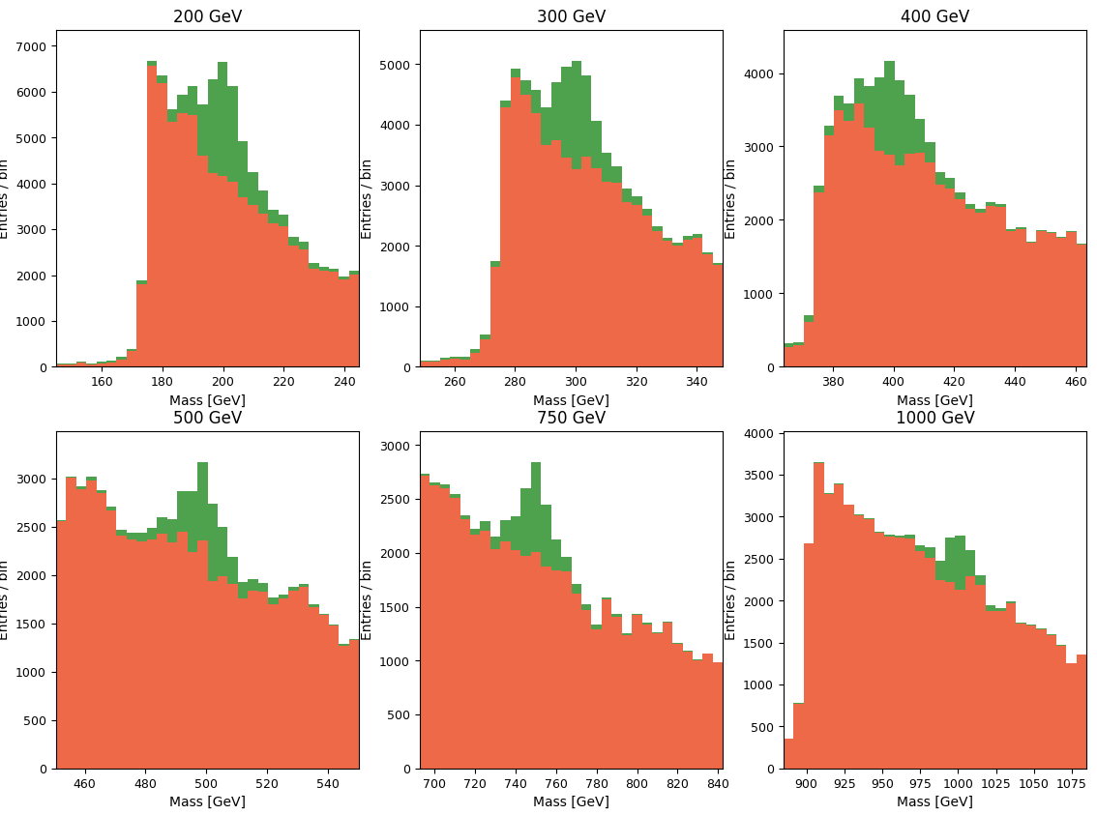
Figure 1
The optimal window sizes were found to be:
  - 200 GeV: $δ=8$
  - 300 GeV: $δ=10$
  - 400 GeV: $δ=8$
  - 500 GeV: $δ=10$
  - 750 GeV: $δ=10$
  - 1000 GeV: $δ=9$
Maximum statistical significance values were obtained for each mass:
  - 200 GeV: 62.52
  - 300 GeV: 49.29
  - 400 GeV: 40.08
  - 500 GeV: 30.30
  - 750 GeV: 27.46
  - 1000 GeV: 18.74

Analysis
The statistical significance as a function of the mass window width $δ$ exhibits a clear maximum for each Z′ mass hypothesis. As $δ$ increases from small values, the significance initially rises because a larger fraction of signal events is included in the counting window. Beyond a certain point, however, further increases in $δ$ lead to the inclusion of more background events, which increases $B$ and reduces the overall value of $S/\sqrt{B}$. This behavior results in a well-defined optimal $δ$ for each mass.
Across all mass hypotheses, the optimal window width is found to be approximately $δ≈8\text{–}10$GeV. This relatively consistent value suggests that the effective width of the reconstructed invariant mass peak is similar for different Z′ masses, likely reflecting the resolution of the reconstruction method rather than the mass scale itself.
The statistical significance decreases with increasing Z′ mass. This trend indicates that the sensitivity of the analysis is reduced at higher energy. Higher-mass Z′ bosons produce fewer signal events, which lowers the value of $S$relative to the background contribution. As a result, even with an optimized mass window, the ability to distinguish signal from background becomes more limited at larger masses.
Discussion
The optimal mass window width is found to be approximately 8–10 GeV for all Z′ mass hypotheses. This result indicates that the choice of windows is largely independent of the assumed Z′ mass within the range studied.
This consistency suggests that the optimal window is primarily determined by the width of the reconstructed invariant mass distribution, which is influenced by the resolution of the reconstruction method. Since the resolution does not change significantly across different mass hypotheses, a similar optimal window width is obtained in each case.
Conclusions
A systematic method for detecting a Z′ boson using invariant mass analysis was successfully developed. By selecting electron–positron events and reconstructing their invariant mass, the analysis provides a clear framework for comparing background-only and signal-plus-background hypotheses.
The optimal mass window for maximizing statistical significance was found to be approximately 8–10 GeV across all tested mass hypotheses. This result indicates that an appropriate selection of the mass window is essential for balancing signal retention and background suppression.
In addition, histogram-based hypothesis comparison effectively highlights resonance structures in the invariant mass distributions. The presence of a localized enhancement near the Z′ mass allows the signal to be distinguished from the smooth background distribution, demonstrating the effectiveness of this approach.
Overall, this study shows that invariant mass reconstruction combined with statistical optimization provides a reliable method for identifying potential signals of new particles in simulated high-energy collision data.
References
[1] Physics 121W Lab Manual: “Optimizing the power of the LHC to search for a new heavy vector boson,” Prof. Whiteson, Spring 2025–26.
[2] E. Howard, “Problems in the Standard Model: from Neutrino Mass to Dark Matter,” 2020. https://www.researchgate.net/publication/342477845_Problems_in_the_Standard_Model_from_Neutrino_mass_to_Dark_matter/link/5efd3e37a6fdcc4ca4448d92/download?_tp=eyJjb250ZXh0Ijp7ImZpcnN0UGFnZSI6InB1YmxpY2F0aW9uIiwicGFnZSI6InB1YmxpY2F0aW9uIn19
[3] A. Alves, S. Profumo, and F. S. Queiroz, “The dark Z′ portal: Direct, indirect and collider searches,” JHEP 04 (2014) 063, arXiv:1312.5281. [1312.5281] The Dark Z' Portal: Direct, Indirect and Collider Searches

